Parts of an Earthquake

Fill in the blanks using the following terms: Fault, Focus, Epicenter

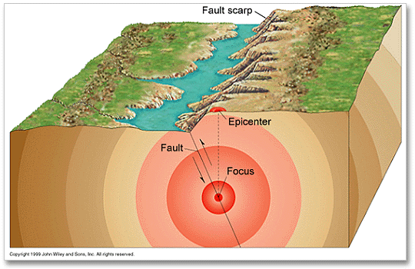

Fill in the blanks using the following terms: Fault, Focus, Epicenter, Seismic Wave

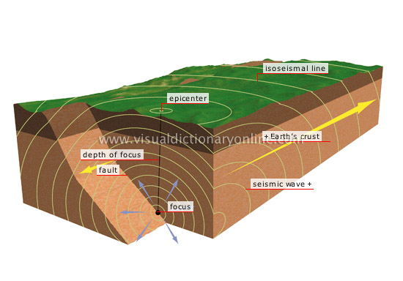
Fill in the boxes using your textbook (pg 498) or the diagrams on the previous page.

Terms: Body Waves, Surface Waves, P Waves, S Waves
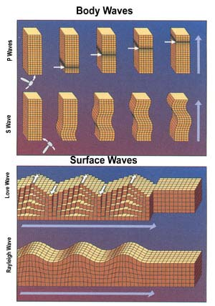

What is the difference between the motion of body waves and the motion of surface waves?

Surface Wave
Secondary Wave
Primary Wave
Description of Wave
Arrival Order
Wave Type
Fill in the following chart using the diagrams above, the textbook section on earthquake waves (pg 498-499), and your notes.

