Name_______________________________ Period____ Date_______
Genetics Study Guide
The Father of Genetics" Review:
- Heredity factors (now called genes) were first investigated by ____________________.
- The results of his first experiment showed that 100% of the offspring had the _________________ trait.
- In his second experiment, _____ fourths of the offspring had the dominant phenotype and _____fourth had the recessive phenotype.
- If a homozygous Tall pea plant is crossed with a homozygous short pea plant, 100%
of the offspring will have a ___________________ genotype.
(adjective)
5. In order for a pea plant to be short, its genotype must be _______.
6. Combining or uniting the 2 gametes is known as ____________________________.
Match the term from column A to its definition in column B.
- Alleles
- Homozygous
- Heterozygous
- Dominant
- Recessive
- Genotype
- phenotype
______7. Different versions of the same gene.
_____ 8. Individuals having two copies of different alleles.
_____ 9. An organisms genetic make-up.
_____ 10. An organisms physical appearance.
_____ 11. The allele that is represented with a capital letter.
_____ 12. The allele that is represented with a lower case letter.
Punnett Practice
Construct Punnett squares for the following crosses and report the predicted percentages for the offspring.
- A mother with attached earlobes (Ee) X A father with free earlobes (ee)
EE -_______%
Attached earlobes –______%
Ee-________%
ee -________% Free earlobes - _____%
- A pea plant with wrinkled seeds (rr) X A pea plant homozygous for round seeds
RR-_____%
Round seeds - _____% Rr-_____%
rr - _____% Wrinkled seeds -____%
- Green pods are dominant to yellow pods. Two pea plants were crossed. They produced 379 offspring with green pods and 127 offspring with yellow pods. This is approximately a 3:1 ratio, or 75% to 25%.
What were the genotypes of the parents in the cross? ___________ X _____________
What were the phenotypes of the parents in the cross? __________ X _____________

Define the following on a separate sheet of paper:
Pedigree
Polygenic Inheritance
Antibody
Sex-Linked Traits
Trisomy
Incomplete Dominance
Multiple Alleles
Autosomes
Monosomy
Agglutination
Codominance
Antigen
Sex Chromosomes
Karyotype
Aneuploidy

Carrier

Genetic Disorders/Diseases:
Fill in the blank below with D if it is a dominant disorder and R if it is a recessive disorder.
Hemophilia _____
Red-Green Colorblindness _____
XO (monosomy X) _____

Cystic Fibrosis _____
Huntington’s _____
Sickle Cell Anemia Co-Dominant
PKU _____

Explain each of the following disorders:
1. Huntington’s Disorder- ____________________________________________________________
2. Cystic Fibrosis - ________________________________________________________________
3. PKU- _________________________________________________________________________
4. Hemophilia - ___________________________________________________________________
Incomplete Dominance vs. Codominance
6. A mating between a black goose and a white goose produces blue-gray offspring. (Blue-gray is an intermediate color between black and white.) Is this an example of incomplete dominance or codominance?_______________________________________________
7. Fill in the phenotypes below for the geese in problem 6.
B B = black
BB’=____________
B'B'=____________
8. Make a Punnett square showing a cross between a black goose and a blue-gray goose. What percentage of offspring would be black?
Answer:__________%
9. A reddish/brown-haired cow when crossed with a white-haired cow produces offspring that have reddish/brown hairs AND white hairs (This color is called roan). Is this an example of incomplete dominance or codominance? _________________________________________
- Fill in the missing genotype and phenotype below for problem 9.
RR = Reddish/Brown
___=Roan
WW = ____________________

- Make a Punnett square that shows the cross described in #9. What percentage of the offspring will be heterozygous?
Answer: __________% %

- The offspring of 2 short-tailed cats have the following phenotypic ratios:
1 no tail : 2 short tails : I long tail
Tail length in these cats is an example of which inheritance pattern?________________________
- Polygenic traits create a ______________________ curve on a graph.
- What is the purpose of a test cross?
Karyotypes
- There are _________ chromosomes in a human somatic cell.

- A male has _________ chromosomes for the 23rd pair and a female has _________ chromosomes for the 23rd pair.

- A person with down syndrome has _____ total chromosomes. They have an extra chromosome in the ___________ chromosome pair.

- A person with Klinefelter’s syndrome has ________ total chromosomes. They have an extra chromosome in the __________ chromosome pair.

- Both down syndrome and klinefelter’s syndrome are a form of ___________because they have an abnormal number of chromosomes.

- A person with Turner’s Syndrome has _______ total chromosomes. They are considered a _____________ because they only have one chromosome 23.
Sex-Linked Traits
- Chromosomes 1-22 are _________________.
- Describe Hemophilia.

- What does it mean if a person has red-green colorblindness?

Multiple Allele Inheritance
- What makes a trait a multiple allele inheritance?
- Who is Charles Drew?
- What role do antigens and antibodies play in blood type?
- Blood type ____ is considered a universal donor because ________________________________.
- Blood Type _______ is considered a universal recipient because _______________________ ____________________________________.
- If type A antigens come in contact with anti A antibodies, the blood will __________________, also called ___________________________.
- A known homozygous red-eyed female fruit fly is crossed with a white eyed male. What genotype and phenotype could they produce and what would be the expected %’s for each?
**In fruit flies, eye color is a sex linked trait.
Phenotypes:
F. Red Eyes –
F. White Eyes-
M. Red Eyes-
M. White Eyes-
Genotypes:
X^{R}X^{R} ____
X^{R}X^{r} ____
X^{r}X^{r} ____
X^{R}Y ____
X^{r}Y ____

- Male and female offspring from your punnett square in #30 are mated with each other. What would be the expected %’s of genotypes and phenotypes?
Genotypes: Phenotypes:

- What is the genotype of a male with hemophilia? ______________________________
- What is the genotype of a female with hemophilia? _____________________________
The pedigree below is for hemophilia within 3 generations of a family.
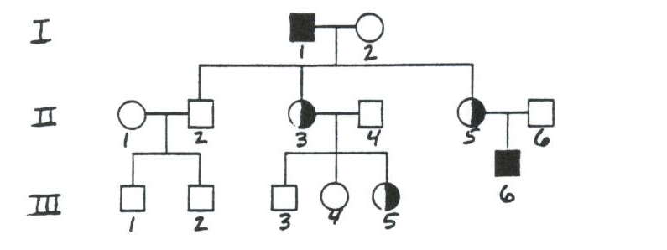
34. List the genotypes for the following individuals: I-1:___________, II-2: ____________
II-5:___________, III-4:___________
35. Study the genotype for a male with hemophilia: X^{h}Y. Can a hemophiliac father pass
hemophilia on to his son? Explain why or why not.
36. How might you tell this was a pedigree (above) for a sex-linked trait if you were not
given that information?

